**Advanced Algorithms**

**Exercise for Lecture 4**

|  |  |  |  |
| --- | --- | --- | --- |
| **Student Name** |  | **Student ID** |  |
| **Problem 1** |  | | |
| **Problem 2** |  | | |
| **Problem 3** |  | | |
| **Problem 4** |  | | |
| **Total Score** |  | | |
| **Notes** | Deadline: **2023-09-14 24:00**  Submission Format: ‘**Lecture4_Name_Student ID.docx**’, and please send to: **[1914499454@qq.com](mailto:algorithms_23fall@163.com)**.  This assignment is meant to be an evaluation of your **individual** understanding coming into the course and should be completed **without collaboration** or outside help. | | |

**Problem 1.[25 points]** Consider a version of the division method in which ℎ(k)=k mod m, where m=2p−1 and k is a character string interpreted in radix 2p. Show that if we can derive string x from string y by permuting its characters, then x and y hash to the same value. Give an example of an application in which this property would be undesirable in a hash function.

【25 points, the answer can get points if it is reasonable】

ANS：

We will show that each string hashes to the sum of it’s digits mod 2p−1.We will do this by induction on the length of the string. As a base case, suppose the string is a single character, then the value of that character is the value of k which is then taken mod m. Now, for an inductive step, let w = w1w2 where |w1| ≥ 1 and |w2| = 1. Suppose, h(w1) = k1.【10 points】

Then, h(w) = h(w1)2p + h(w2)mod 2p − 1 = h(w1) + h(w2) mod 2p − 1. 【20 points】So, since h(w1) was the sum of all but the last digit mod m, and we are adding the last digit mod m, we have the desired conclusion.【25 points】

**Problem 2.[25 points]** Suppose that we use double hashing to resolve collisions—that is, we use the hash function h(k,i)=(h1(k)+ih2(k)) mod m. Show that if m and h2(k) have greatest common divisor d≥1 for some key k, then an unsuccessful search for key k examines (1/d)th of the hash table before returning to slot h1(k). Thus, when d=1, so that m and h2(k) are relatively prime, the search may examine the entire hash table.

【25 points, the answer can get points if it is reasonable】

ANS:

Write h2(k) = dc1 and m = dc2 for constants c1 and c2. When we have examined (1/d)th of the table entries, this corresponds to m/d = c2 of them. 【15 points】The entry that we check at this point is [h1(k) + (m/d)h2(k)] mod m = [h1(k) +(m/d)(dc1)] mod m ≡ h1(k). When d = 1, we may have to examine the entire hash table.【25 points】

**Problem 3.[25 points]** Suppose that we use an open-addressed hash table of size m to store n ≤ m/2 items. Assuming uniform hashing, show that for i = 1, 2..n, the probability is at most 2−k that the i-th insertion requires strictly more than k probes.

【25 points, the answer can get points if it is reasonable】

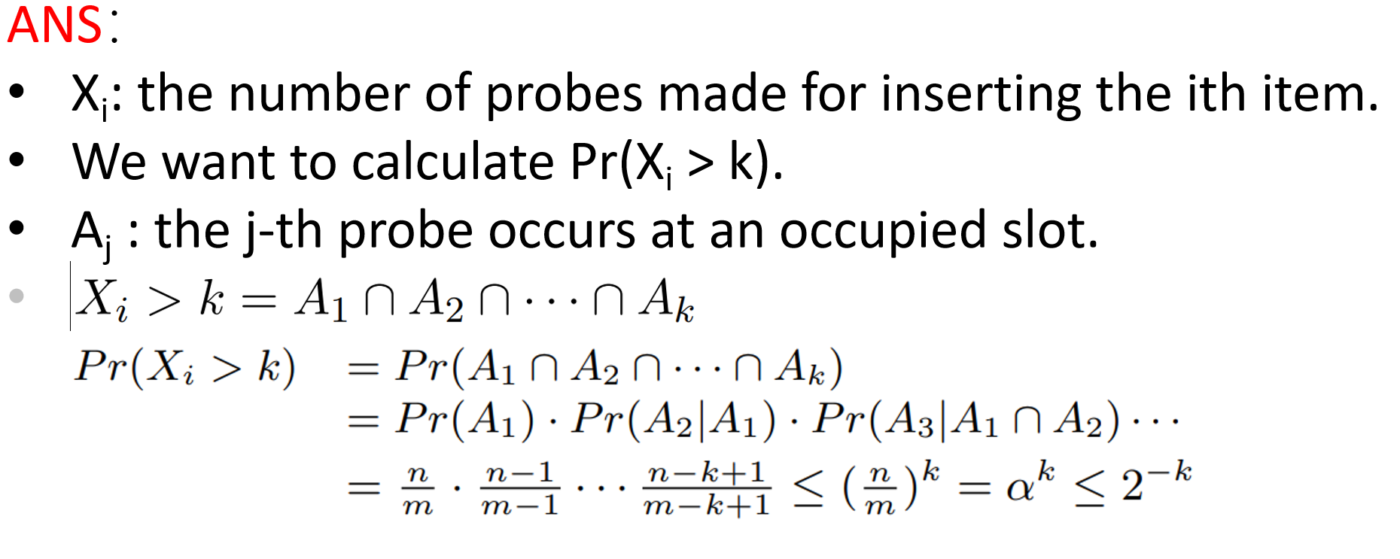

【10 points】

【20 points】

【25 points】

**Problem 4.[25 points]** Suppose that we have a hash table with n slots, with collisions resolved by chaining, and suppose that n keys are inserted into the table. Each key is equally likely to be hashed to each slot. Let M be the maximum number of keys in any slot after all the keys have been inserted. Your mission is to prove an O(lgn/lglgn) upper bound on E[M], the expected value of M. Argue that the probability Qk that exactly k keys hash to a particular slot is given by

Qk =

【25 points, the answer can get points if it is reasonable】

